**Ashutosh Jha (11811)**

**Case Study 5 : SD Models**

**Q)** You are required to give real-time applications of every model in terms of when, Where, How it is used by giving advantages and disadvantages.

* Incremental approach
* Waterfall model
* Agile Model
* Prototyping model
* Spiral model

**Ans)**

1. Incremental Approach*:* In an Incremental Model, each module passes through the requirements, design, testing and implementation phases.

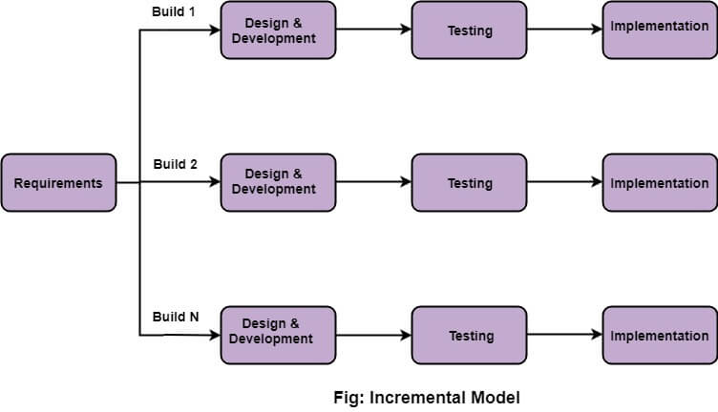

In the diagram, when we work incrementally we are adding piece by piece but expect that each piece is fully finished.

Advantages of this model are as follows:

* + It is easier to test and debug during a smaller iteration.
  + In this model customers can respond to each build.
  + Lowers initial delivery cost.

Disadvantages of this model are as follows:

* + Needs good planning and design
  + Needs a clear and complete definition of the whole system before it can be broken down and built incrementally.
  + Total cost is higher than the waterfall.

1. Waterfall Model*:* Waterfall model was used to develop enterprise applications like Customer Relationship Management (CRM) systems, Human Resource Management Systems (HRMS), Supply Chain Management Systems, Inventory Management Systems, Point of Sales (POS) systems for Retail chains etc.

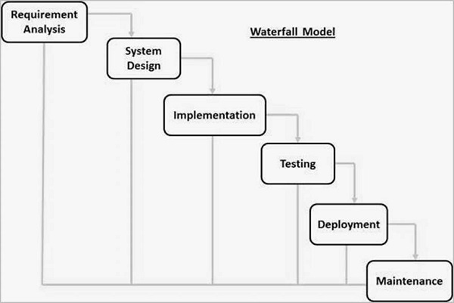

Advantages of this model are as follows:

* + This model is simple and easy to understand and use.
  + It is easy to manage due to the rigidity of the model, each phase has specific deliverables and a review process.
  + In this model phases are processed and completed one at a time. Phases do not overlap.

Disadvantages of this model are as follows:

* + No working software is produced until late during the life cycle.
  + High amounts of risk and uncertainty.
  + Not a good model for complex and object-oriented projects.

1. Agile Model*:* Agile software development methodology is a process for developing software. Agile means ‘ability to move quickly and easily’ and responding swiftly to change. This is a key aspect of Agile software development as well.

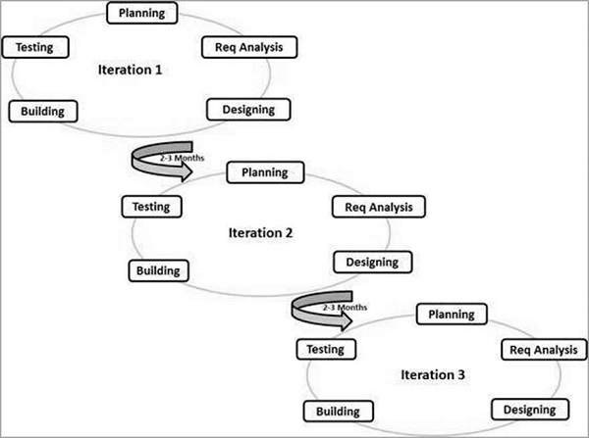

Advantages of this model are as follows:

* + In Agile methodology the daily interactions are required between the business people and the developers.
  + In this methodology attention is paid to the good design of the product.
  + Changes in the requirements are accepted even in the later stages of the development.

Disadvantages of this model are as follows:

* + Sometimes in Agile methodology the requirement is not very clear hence it’s difficult to predict the expected result.
  + In few of the projects at the starting of the software development life cycle it’s difficult to estimate the actual effort required.
  + The projects following the Agile methodology may have to face some unknown risks which can affect the development of the project.

1. Prototyping Model*:* Prototyping Model is a software development model in which a prototype is built, tested, and reworked until an acceptable prototype is achieved. It also creates a base to produce the final system or software. It works best in scenarios where the project's requirements are not known in detail. It is an iterative, trial and error method which takes place between developer and client. Each loop of the spiral is called a Phase of the software development process.

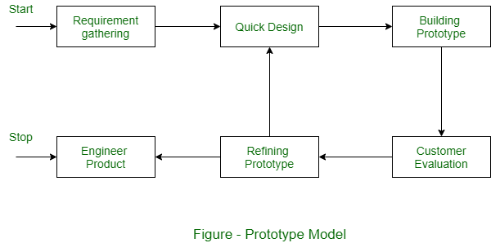

Advantages of this model are as follows:

* + Users are actively involved in development. Therefore, errors can be detected in the initial stage of the software development process.
  + Missing functionality can be identified, which helps to reduce the risk of failure as Prototyping is also considered as a risk reduction activity.
  + Helps team member to communicate effectively

Disadvantages of this model are as follows:

* + There may be far too many variations in software requirements each time the prototype is evaluated by the customer.
  + Sometimes customers may not be willing to participate in the iteration cycle for the longer time duration.
  + Prototyping is a slow and time taking process.

1. *Spiral Model:* In this model, we create the application module by module and hand it over to the customer so that they can start using the application at a very early stage. And we prepare this model only when the module is dependent on each other. In this model, we develop the application in stages because sometimes the client gives the requirements in between the processes.

In the spiral model, the software is developed in the small modules. Suppose we have the application A and this A application is created with the help of different models as P, Q, R.

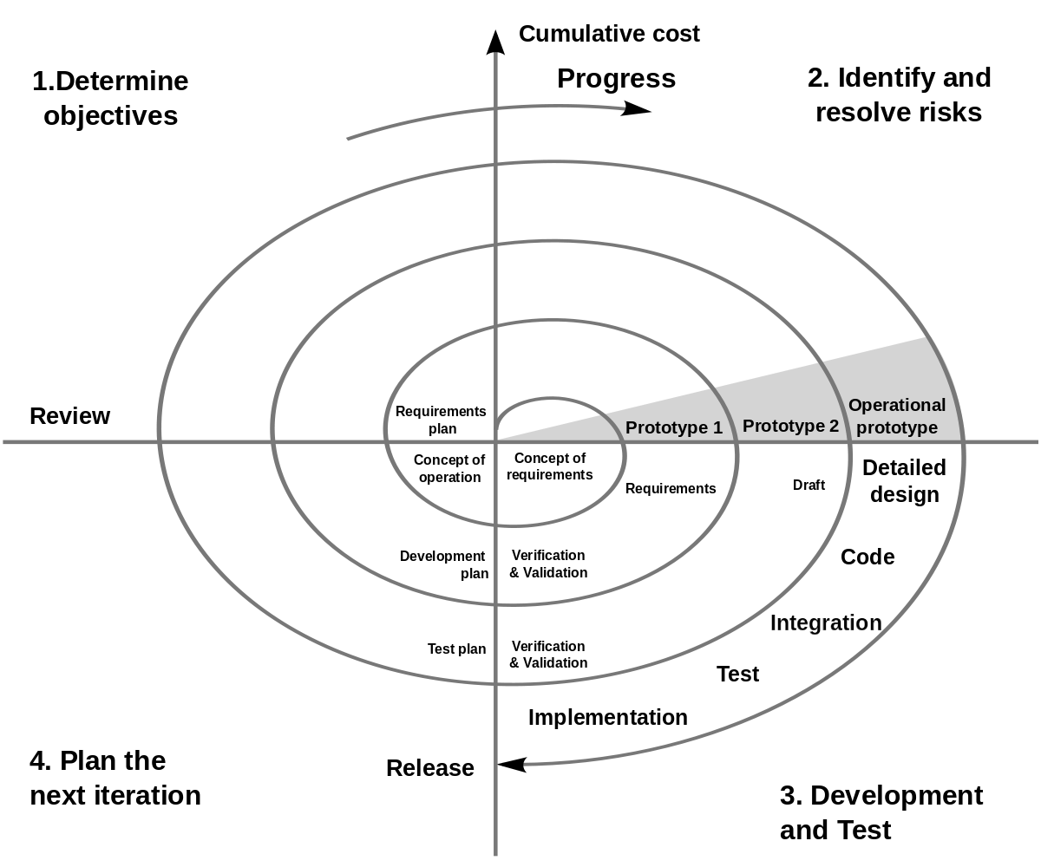

Advantages of this model are as follows:

* + Best for a high risk project
  + Good for large and mission-critical projects
  + Strong approval and documentation control

Disadvantages of this model are as follows:

* + Time-consuming and costly
  + Risk of not meeting the budget or schedule
  + Very hard to properly monitor and maintain